Data and Artificial Intelligence

Cyber Shujaa Program

Week 2 Assignment
Data Wrangling and Analysis (Netflix Dataset)
Student Name: Rodney Roy Gitonga
Student ID: CS-DA03-26025

Introduction
This week’s assignment focused on Data Wrangling, a critical step in the data science pipeline where raw data is cleaned and transformed into a format suitable for analysis. The task involved working with the Netflix Movies and TV Shows dataset hosted on Kaggle.
Using Python and the Pandas library within a Kaggle Notebook, I performed data discovery to understand the dataset's structure, applied cleaning techniques to handle missing values and duplicates, and enriched the data by extracting new features.
The objectives of the assignment were:
- Load the Netflix dataset and perform exploratory data discovery.
- Clean the dataset by handling duplicates and formatting inconsistencies.
- Impute missing values for the 'Director' and 'Country' columns using logical relationships with other columns.
- Transform the 'Duration' column into usable numeric data.
- Validate the logical consistency of dates (e.g., ensuring content isn't added before it is released).
- Export the polished dataset to a .csv file.

Tasks Completed
Below is the sequence of tasks completed to clean the dataset, supported by code snippets and evidence of execution.

Step 1: Data Discovery
I loaded the dataset using pd.read_csv and inspected its structure using .shape and .isnull().sum(). This revealed missing values in the Director, Cast, and Country columns that needed addressing.
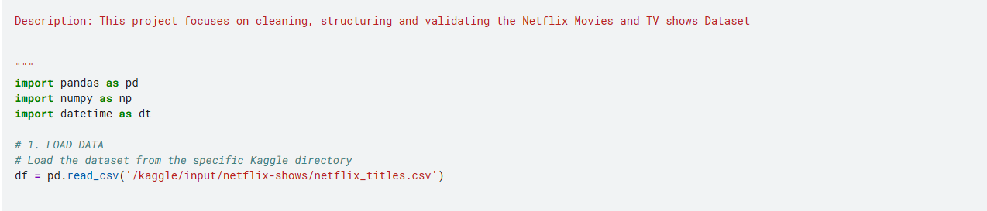

Step 2: Structuring and Feature Extraction
To make the data analysable, I converted the date_added column to a datetime object. I also split the duration column (e.g., "90 min") into two separate columns: duration_value (numeric) and duration_unit (text).
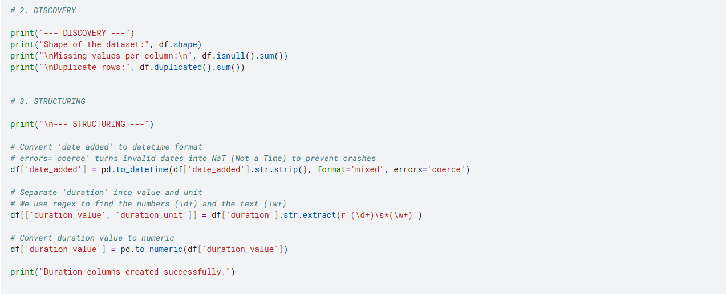
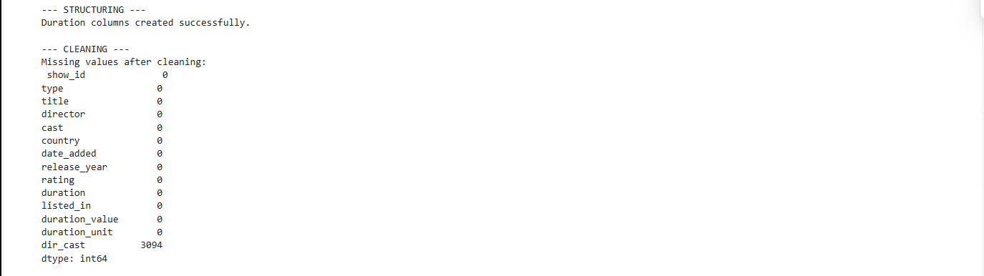

Step 3: Data Cleaning and Imputation
I removed exact duplicate rows to ensure data integrity. For missing 'Director' and 'Country' values, I implemented a logic to fill them based on relationships (e.g., if a specific Cast member frequently works with a Director, I used that to fill missing Director names). Remaining nulls were labelled as "Not Given".
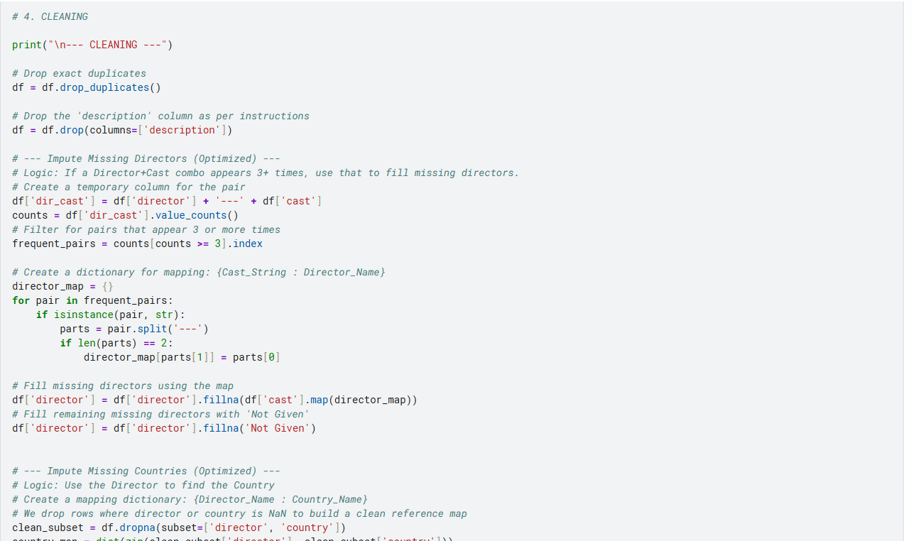
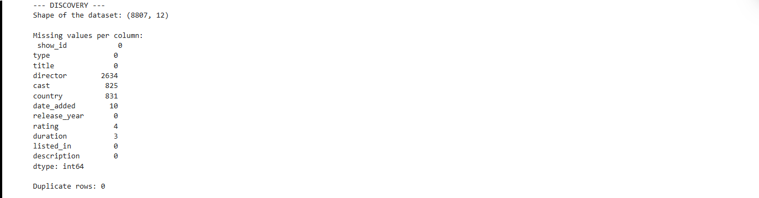

Step 4: Validation
I performed a logical check to ensure that the date_added was not earlier than the release_year. Inconsistent records were identified and removed to maintain accuracy.
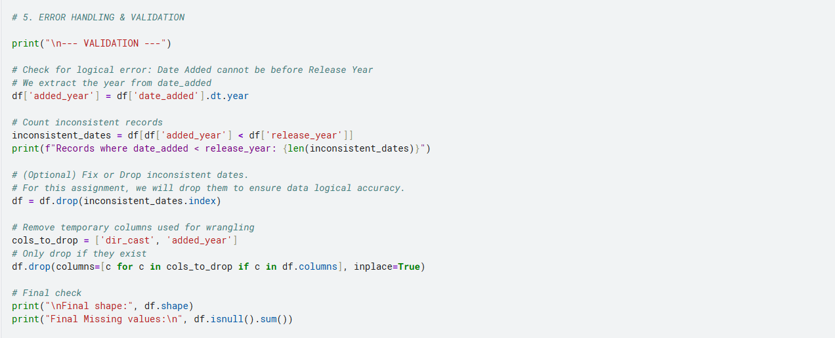
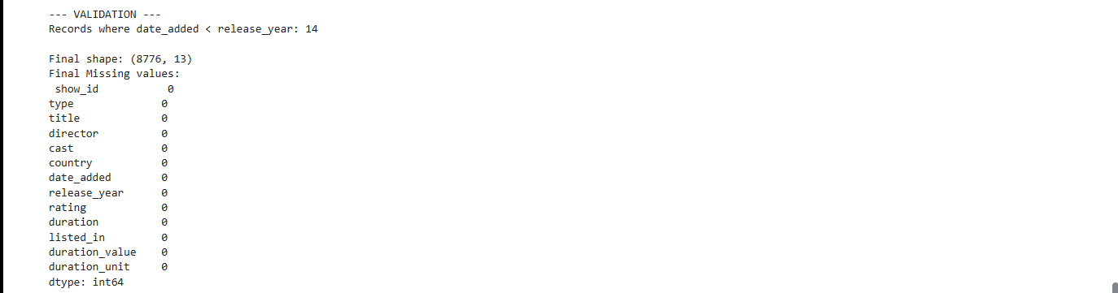

Step 5: Publishing
The final cleaned dataset was exported to the Kaggle working directory.
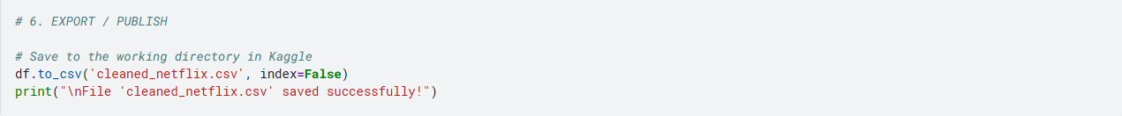

Link to Code:
https://www.kaggle.com/code/fytroy/rodney-roy-gitonga-data-wrangling

Conclusion
Through this assignment, I learned that real-world data is rarely ready for immediate analysis. I gained hands-on experience with advanced Pandas functions, including regex for string extraction and mapping dictionaries for data imputation. I also understood the importance of validating data logic (such as date consistency) before finalizing a dataset. This project has strengthened my ability to transform raw, messy data into a structured format, a crucial skill for my future work in Data and AI.

